Ideation Phase

Define the Problem Statements

|  |  |
| --- | --- |
| Date | 03 November 2023 |
| Team ID | NM2023TMID07783 |
| Project Name | Brand Name, Brand Mail And Brand Logo In Canva |
| Maximum Marks | 2 Marks |

Customer Problem Statement Template:

Create a problem statement to understand your customer's point of view. The Customer Problem Statement template helps you focus on what matters to create experiences people will love.

A well-articulated customer problem statement allows you and your team to find the ideal solution for the challenges your customers face. Throughout the process, you’ll also be able to empathize with your customers, which helps you better understand how they perceive your product or service.

Example:

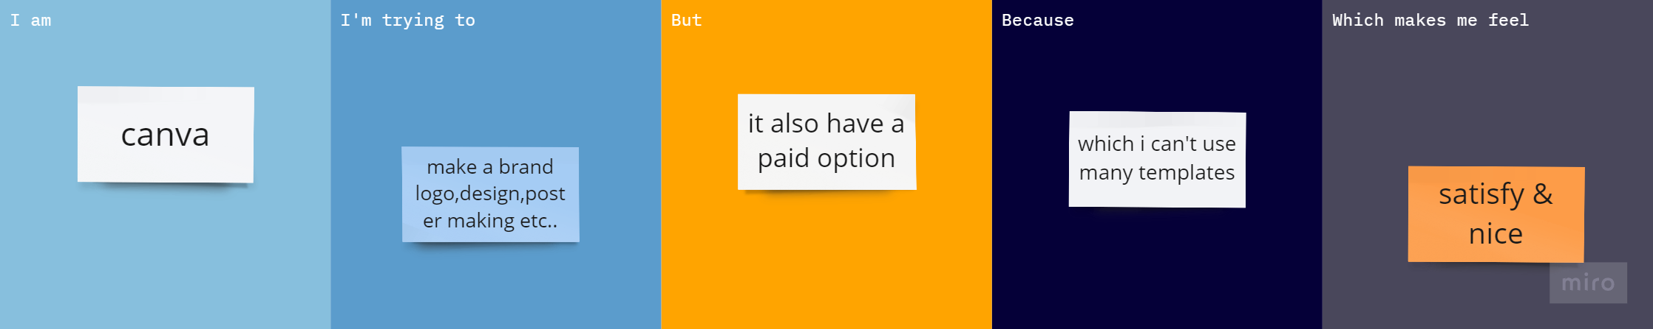

|  |  |  |  |  |  |
| --- | --- | --- | --- | --- | --- |
| Problem Statement (PS) | I am (Customer) | I’m trying to | But | Because | Which makes me feel |
| PS-1 | Use a Strong Password | Create a strong and unique password for your Canva account. | Cost effective | Avoid using easily guessable information like your name or common words. Use a combination of upper and lower-case letters, numbers, and special characters. | Ensuring the security of your Canva account and the data you store in it is essential, as it contains potentially sensitive information and designs. |
| PS-2 | **Project Saving and Loading** | Users should be able to save and load their design projects without delays or errors. | Requires more sensors | Frequent saving and automatic backups can help mitigate data loss in case of performance issues. | using a high-speed internet connection, regularly saving your work, and being mindful of the complexity of your designs to avoid performance issues. Additionally, keeping your web browser and the Canva app up to date can help ensure optimal performance. |